**WFMH REGIONAL CONGRESS, SINGAPORE**

**1-3 October 2015**

*“Innovations in Mental Health Care through Holistic Interventions in the Asia Pacific Region”*



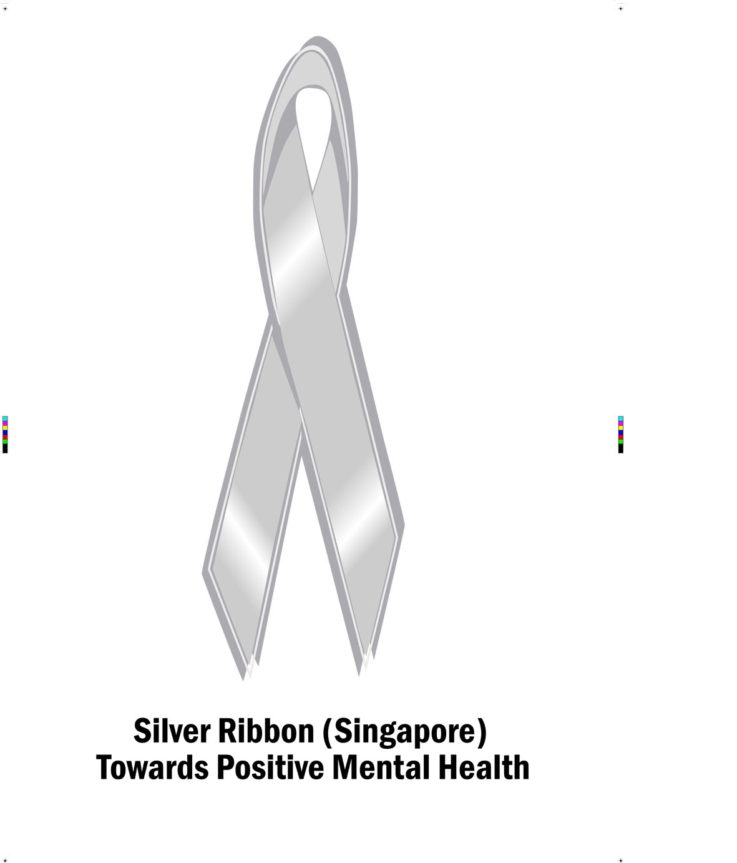

WFMH will hold an Asian Regional Congress in Singapore on 1-3 October 2015, co-hosted by Raffles College of Higher Education and Silver Ribbon Singapore

([www.wfmhsingapore2015.com](http://www.wfmhsingapore2015.com)). The meeting will be held at the Fairmont Hotel. The Congress planners have assembled a large group of local agencies and organizations to support the conference.

Abstract submission is now open: the deadline is 8 May 2015. For program information, registration and abstract submission, please go to the Congress website at: wfmhsingapore2015.com

The Early Bird rate is available until 7 July (Singapore$ 550; Singapore$ 200 for students). The program includes plenaries on the challenges for WFMH; mental health promotion in Hong Kong; the role of primary care in treating comorbid mental and physical health conditions; person-centered integrated care through innovative service design; global action on addictions; and advocacy. Singapore’s Minister of Health and two Members of Parliament will address the conference.

Tracks include holistic approaches to mental health care; community mental health; influencing youth mental wellbeing and health; improving physical health for patients with mental illness; and the role of peer specialists. The program on the third day includes site visits to the Caregivers Alliance Limited; the Singapore Anglican Community Services – Hougang Care Centre; or the Institute of Mental Health.

*Silver Ribbon (Singapore)* is a non-profit organization launched by Singapore’s former President Nathan in 2006 to combat mental health stigma and encourage early treatment. It is very active in community education. The founding Executive Director is Porsche Poh, a WFMH Board member and co-chair of the Congress.

*Raffles College of Higher Education* in Singapore has an international faculty and is part of a network of colleges in major cities in Australia, Cambodia, China, India, Indonesia, Malaysia, Mongolia, Sri Lanka, Thailand, Philippines and Saudi Arabia. Dr. Monica Walet, the Academic Director of Raffles College and Program Director of Postgraduate Studies and Psychology, is co-chair of the Congress with Ms. Poh.

**********