MOTORCYCLE RALLY FOR AWARENESS ON MENTAL HEALTH.
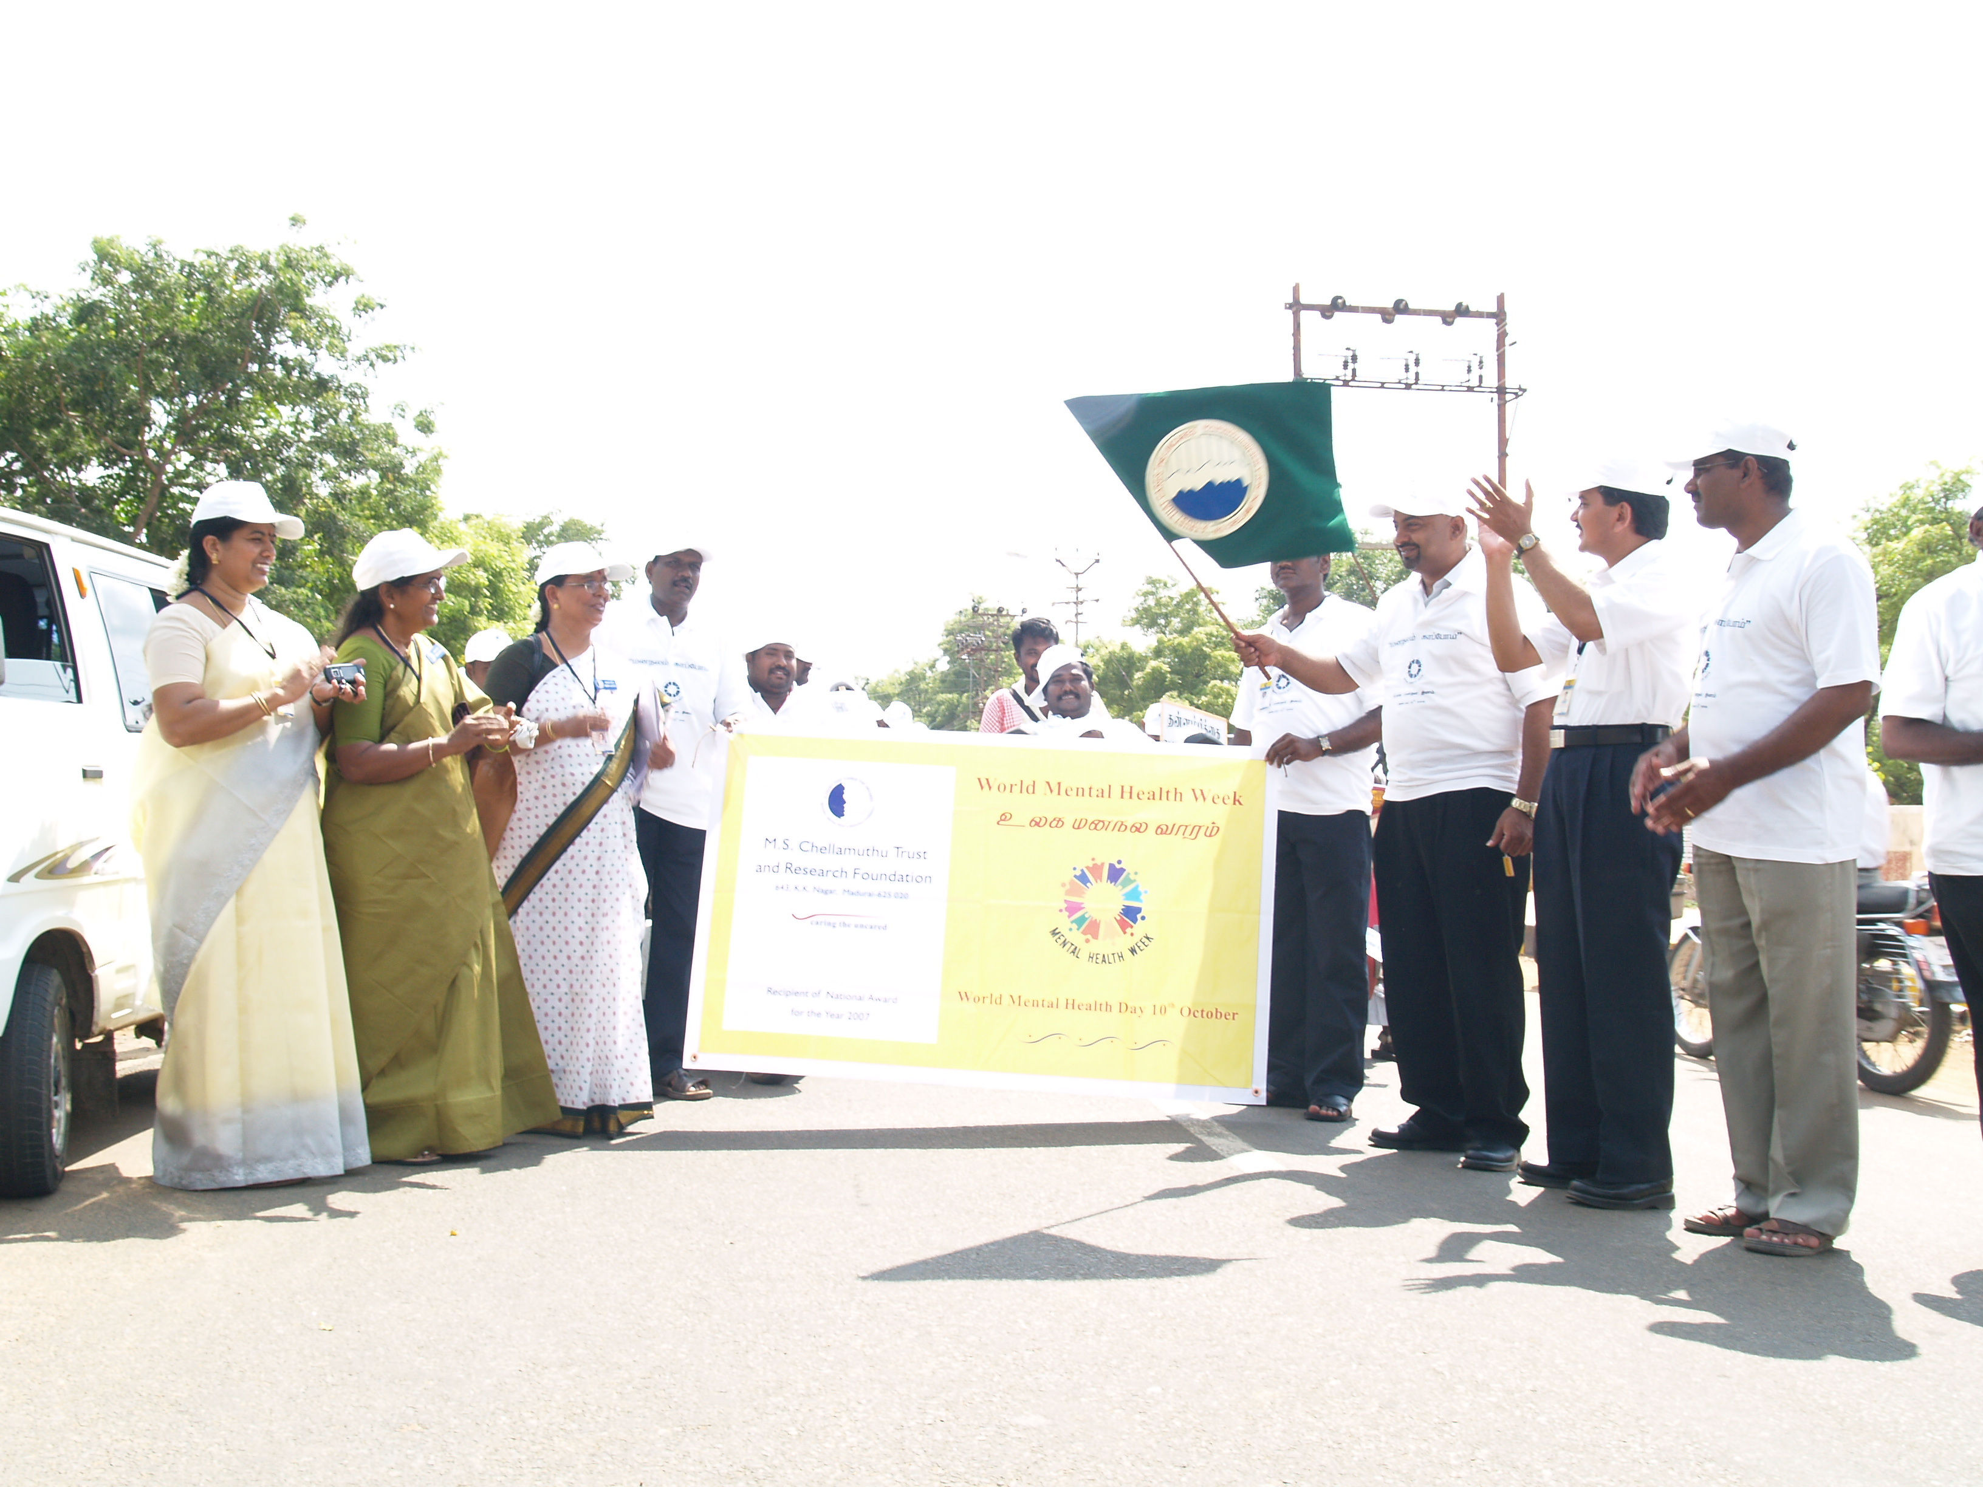

Thiru.L.Murali Krishnan inaugurating the motorcycle rally

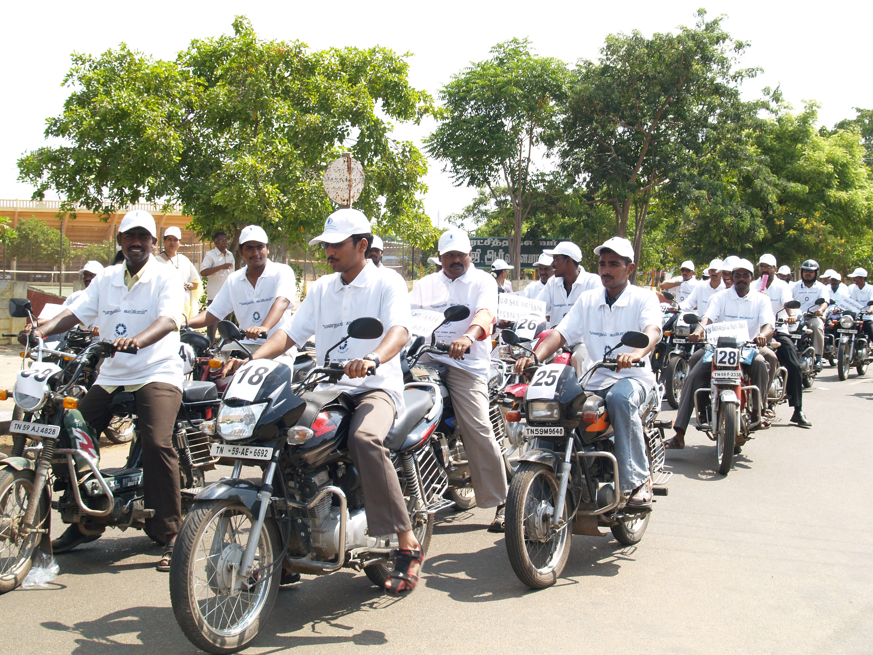

NSS volunteers of Madurai Kamaraj University participated in the rally

CAREGIVERS MEET AT PSYCHO SOCIAL REHABILITATION CENTRE

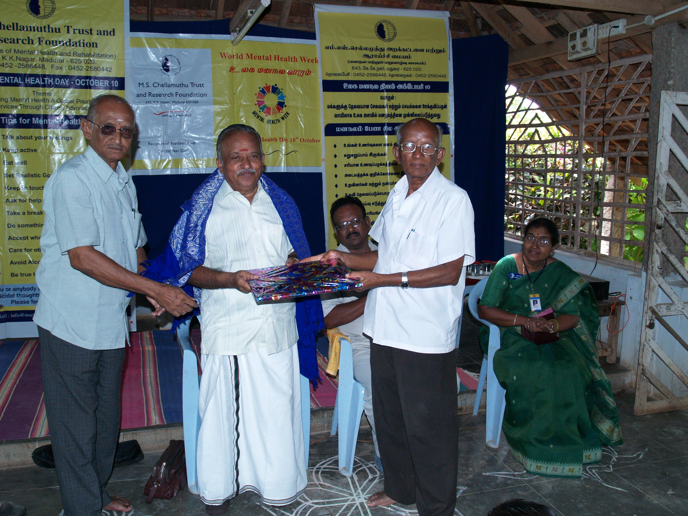

Thiru.Muthaiah, being honoured by the caregivers

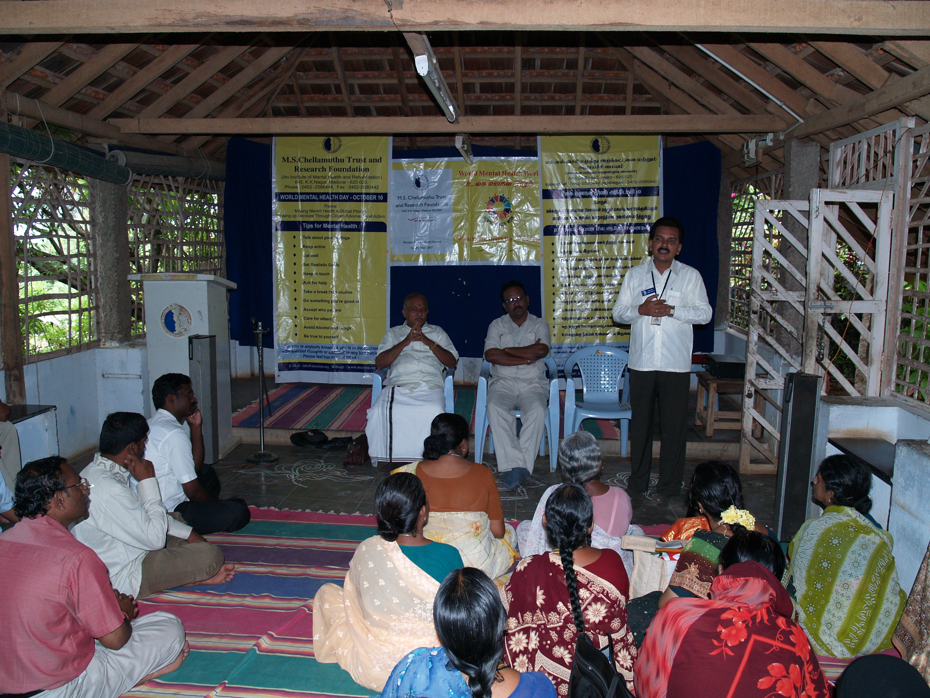

Sharing of caregivers

MENTAL HEALTH AWARENESS CAMPAIGN AT RAMNAD

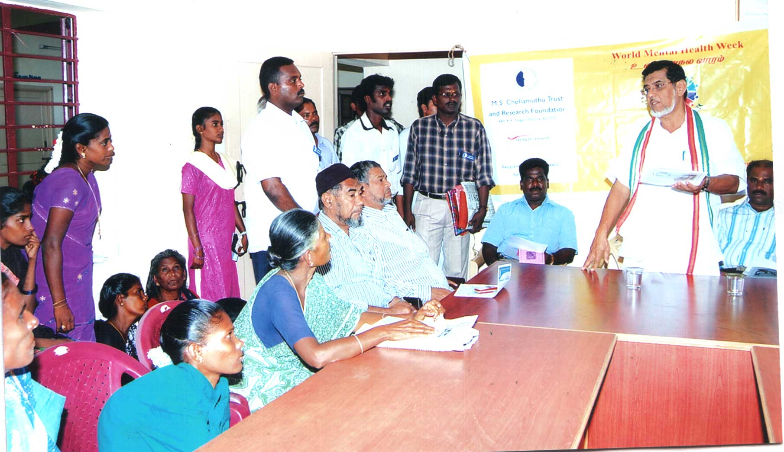

key note address by Thiru.Hasan Ali.
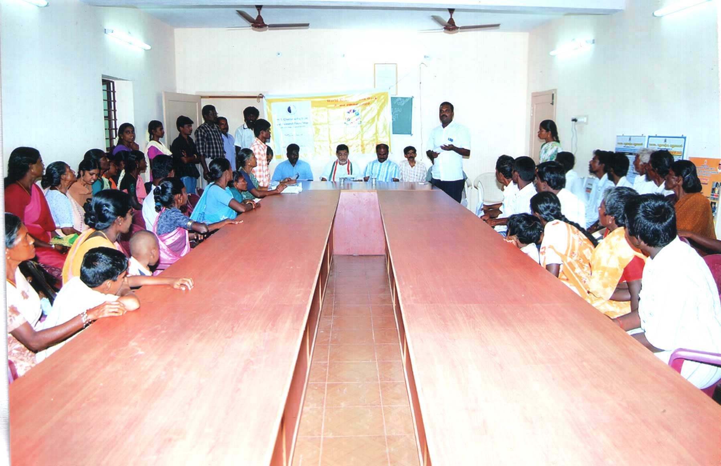

Tips on mental health given by our Project Coordinator

