Hywel’s E-Voice
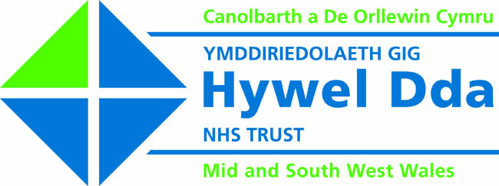

Issue ???

Mind The Gap Conference - Dispelling The Myths Around Mental Health
Hywel Dda NHS Trust commemorated World Mental Health day in the third of a series of events called ‘Mind The Gap’ The event was held in Morlan, Aberystwyth. Over 80 people attended. Which included service users; however, the target audience for the day were non mental health practitioners from health and social care. The new Director for Nursing and Quality attended as well as some non executive members of the new Trust Board.
This year's theme addressed the continuing need to “make mental health issues a global priority”,and to stress the all too-often neglected fact that mental health is a universal concern, it can occur in all cultures and at all stages of the life span.
The Trust joined voluntary mental health organisations, professional associations, government agencies, schools, and mental health service agencies in more than 100 countries to commemorate the 16th annual World Mental Health Day campaign. The priorities are to increase the public’s understanding of mental illnesses, encourage the reduction of stigma and discrimination against people living with a mental illness, and promote positive emotional wellness are planned however we will be looking at holding similar events throughout the 3 counties to continue challenging the stigma and inequalities that are still associated with mental health problems.
People commented on being able to network via various table/poster displays and enjoyed the different aspects covered in the talks through out the day.
No further events are planned however we will be looking at holding similar events throughout the 3 counties to continue challenging the stigma and inequalities that are still associated with mental health problems.

.

.

Page 1
Page 1



Topics covered at the event

- Facts and myths about mental illness- Jayne Anderson and Bleddyn Lewis

- Stepping Stones – one step at a time – Richard Jones

- Mental Health Act- Hassen Joomraty

- A personal and professional view of ‘the gap’ - Kathy Giles

- A co-ordinated approach to care – Bleddyn Lewis

- ‘Closing the gap’ DVD

- All my health needs – Jayne Anderson

- Mind your heart –Jan Batty

- Interactive session - Making the Difference

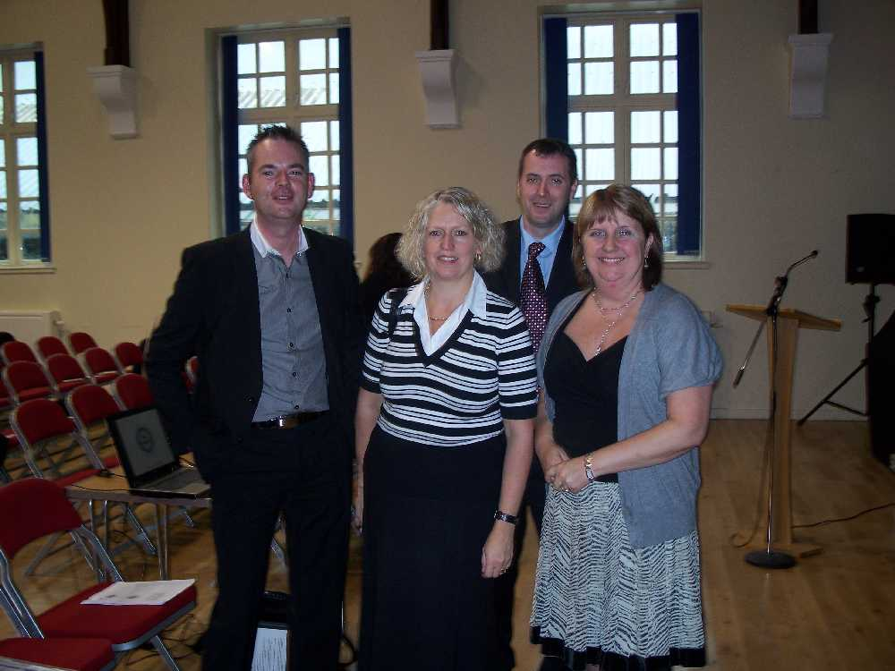

MH Physiotherapy – Nicholas Evans

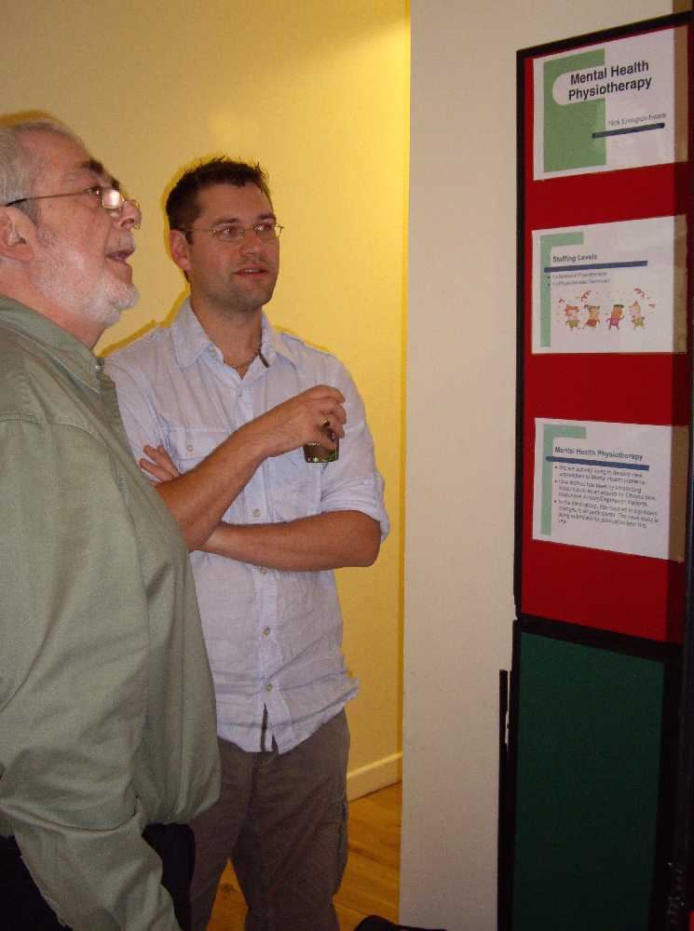

Integrated Care Management Team – Sarah Brain and Tracy Davies
FACE, Digital Pen Pilot, Physical Health and Integrated Care Management.

CAMHS – Sue West, Diane Williams and Angela Lodwick
Self Harm, Eating disorders and primary care for child and family services.

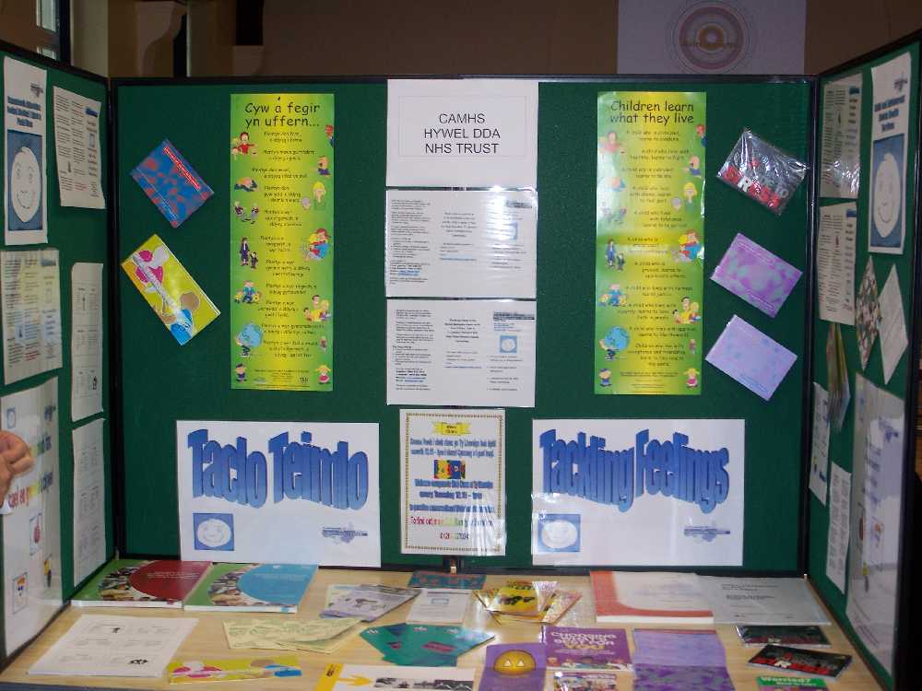

Enlli Ward – Debbie Chattun and Sally Corlett

Learning Disabilities – Nigel Miller
Signing demonstration with service user.

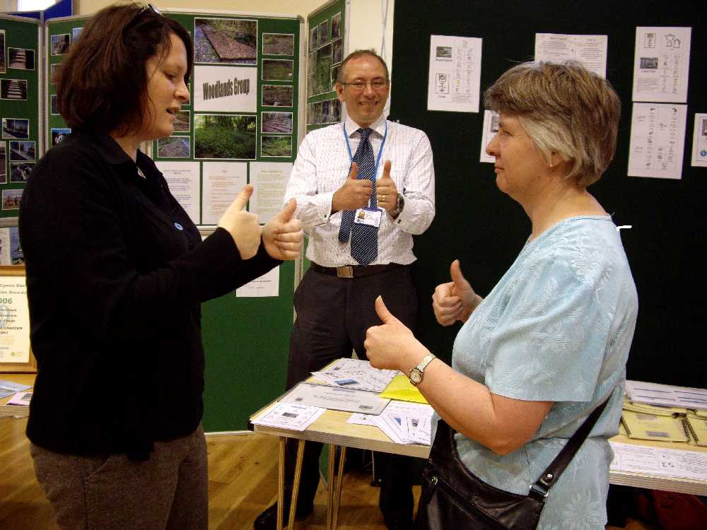
South Ceredigion CMHT – Tyrone Brown and Lesley Levy
Coastcare and woodland group projects
Tyrone’s comments on the day ‘I felt the event went very well, we had excellent feedback with our display board & a lot of interest from people. It was a very nice venue, Lesley & I were very grateful with our prize. Thank you for organizing the day’
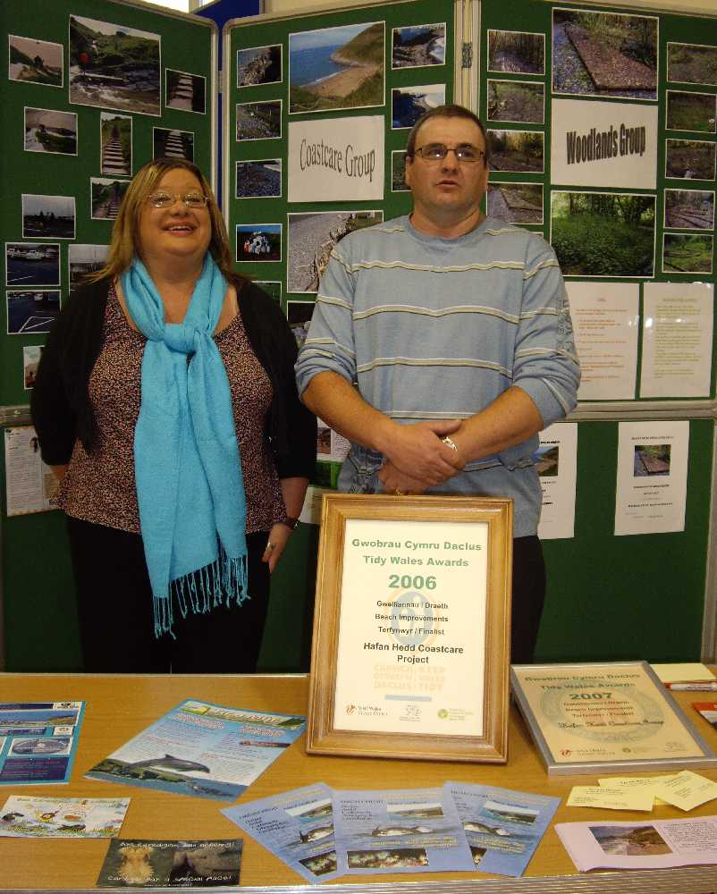

Afallon Ward – Christine Whipp and Lloyd Bloomfield

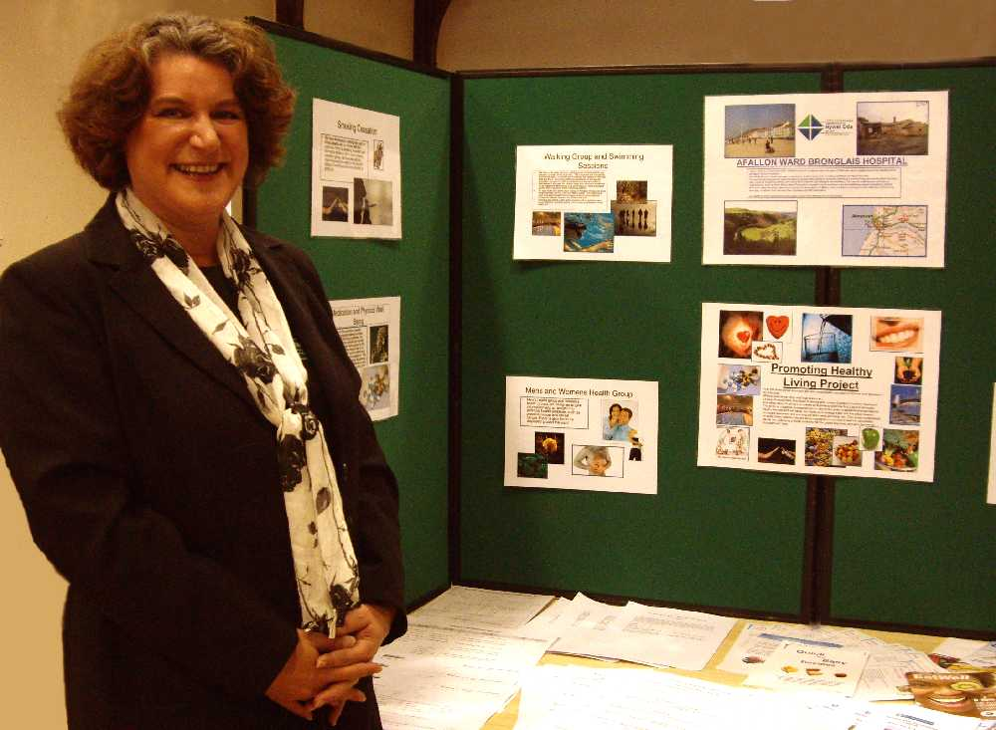

Ceredigion AOT – Donna Phillips and Kate Lewis

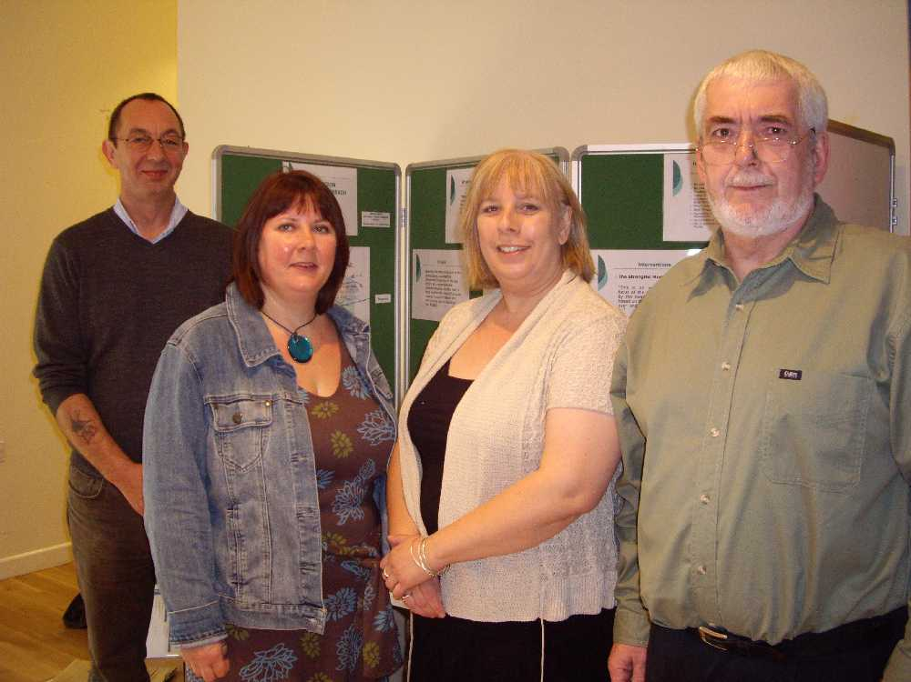

Primary Care Mental Health Team – Tamsin Meriel
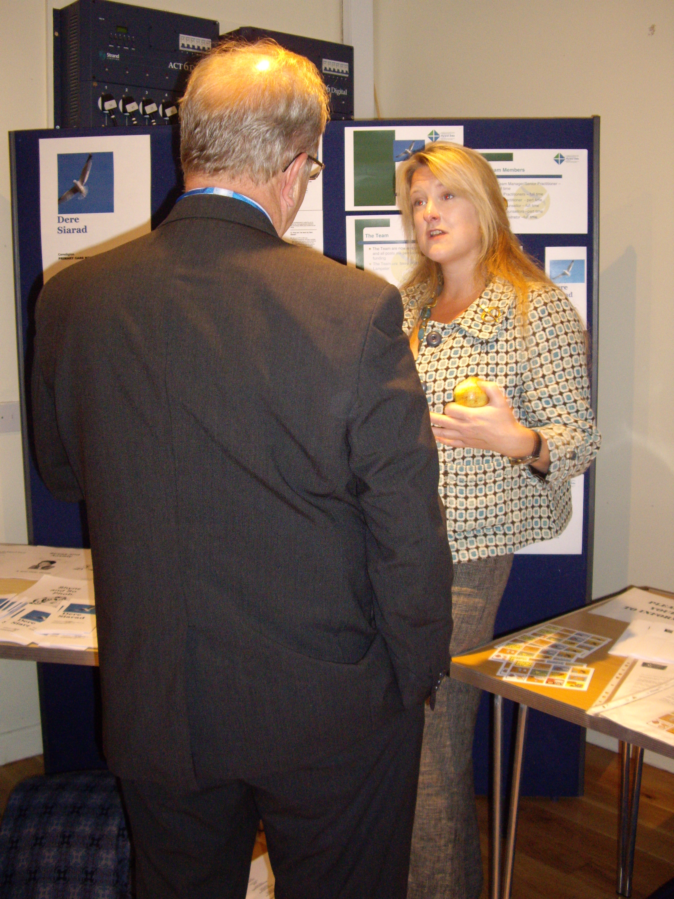
Trust Posters and Table Displays

Page 2
Voluntary Sector Posters and Table Displays

Mind Your Heart – Jan Batty

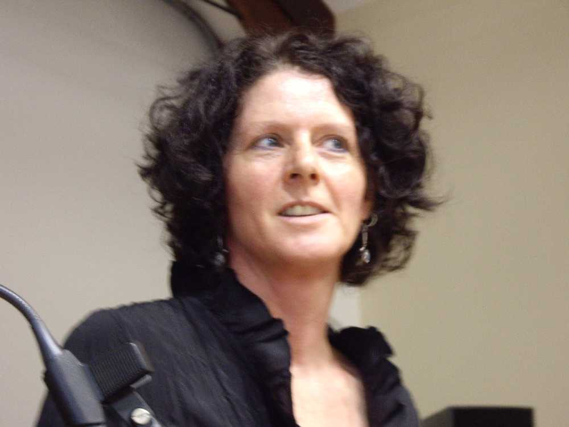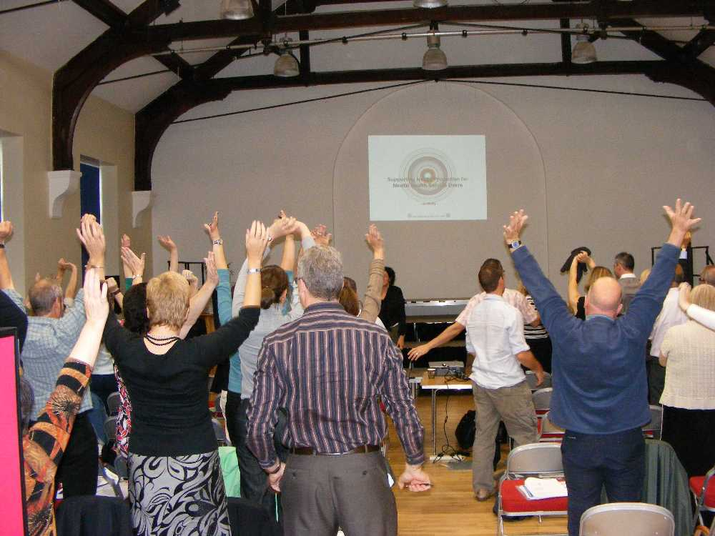

Well Being Support Programme –Annette Jones
Looking at the physical health of people with a serious mental illness
Annette has Well-Being training events are scheduled for the following dates, 18th and 19th March 2009 and 22nd and 23rd April 2009. To book onto these training days please email Annette.hoyland@pdt-tr.wales.nhs.uk.

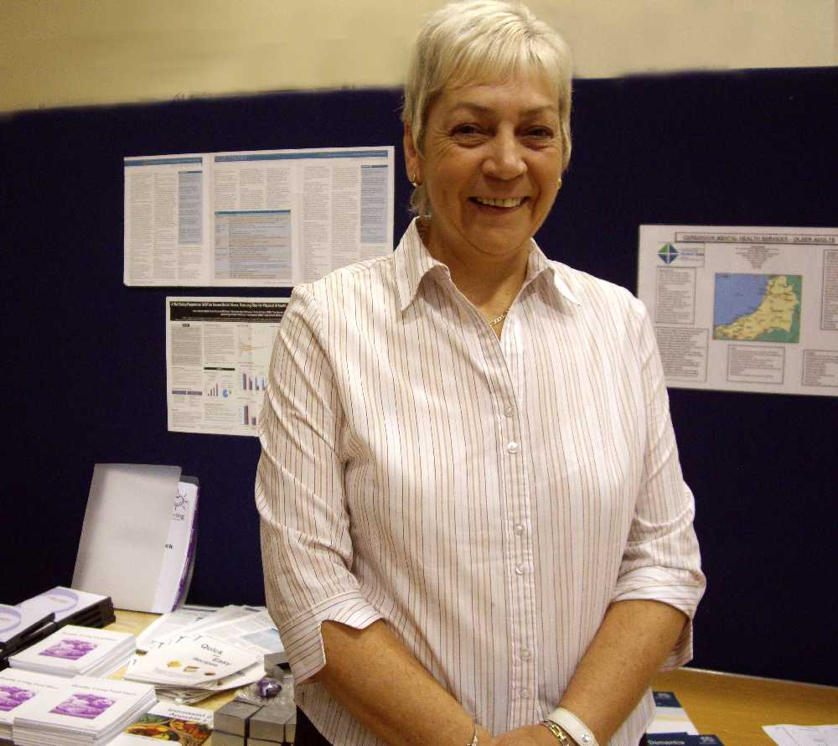

WWAMH – David Rabjohns

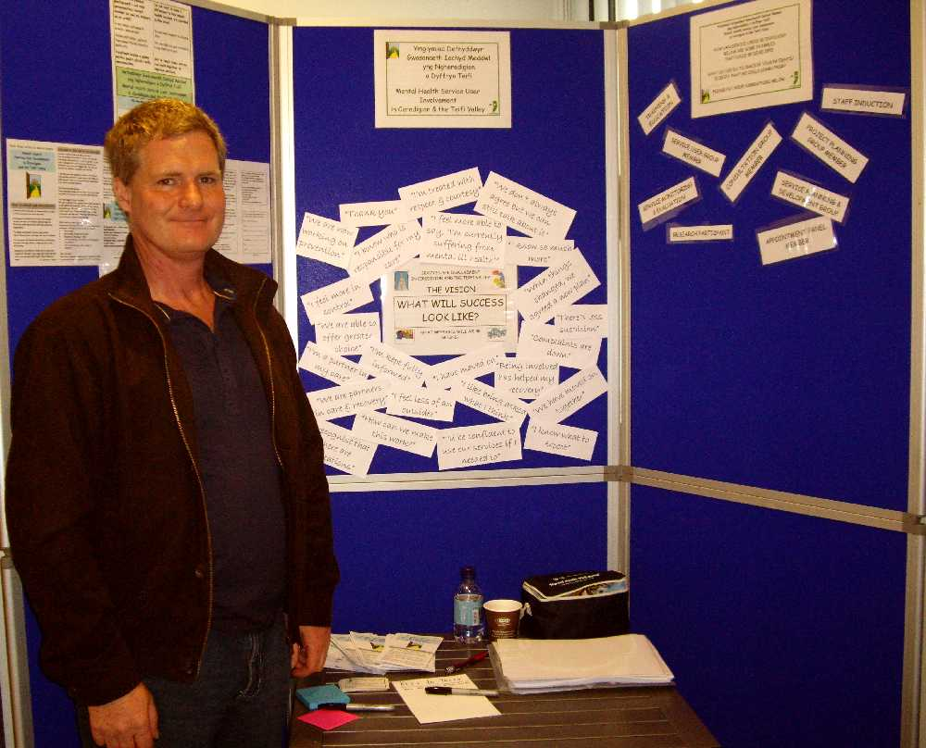

Mind Aberystwyth – Joyce Borgs
Health & Wellbeing Centre


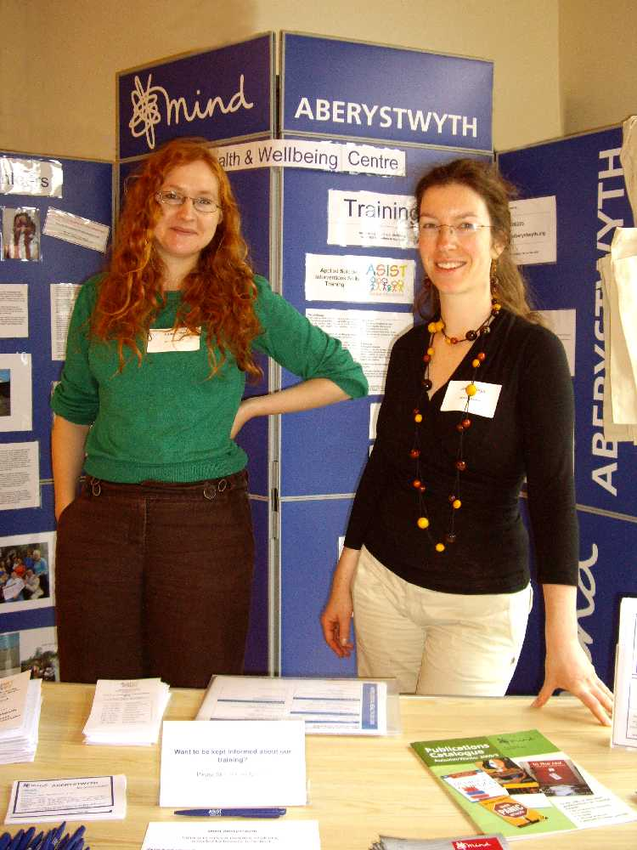

Crossroads/Enlli – Julia Andrew

Condition Management Programme – Sally Waters

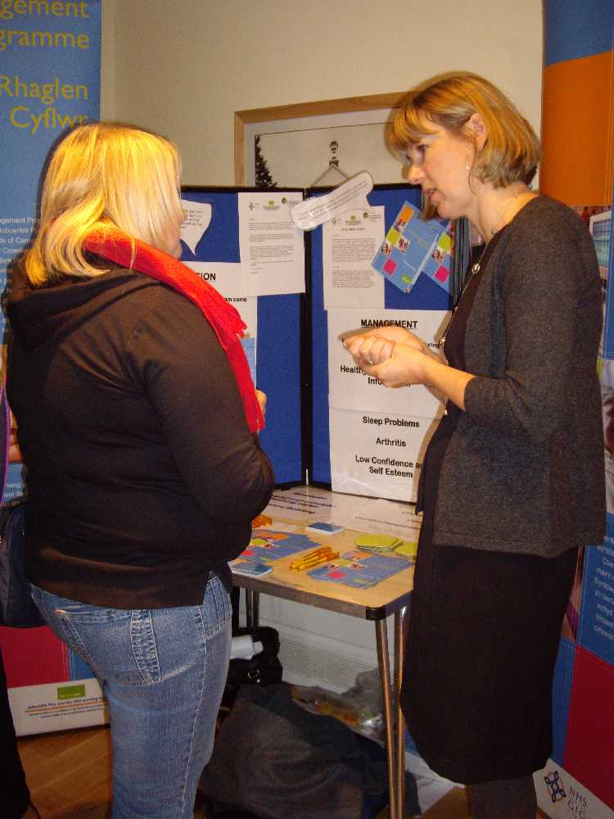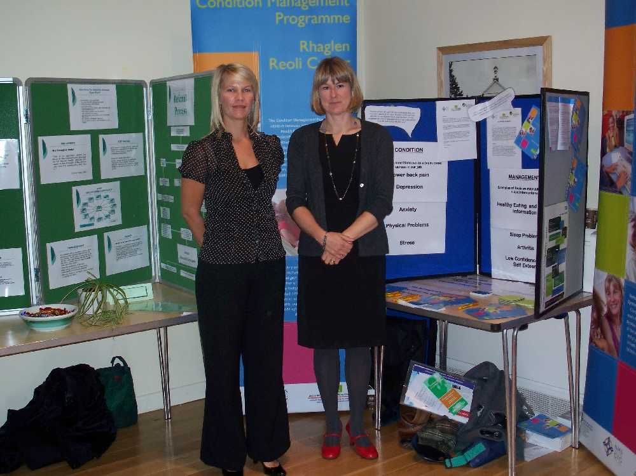
Page 3
Hafal – Rik Mowbray and Bob Mathias

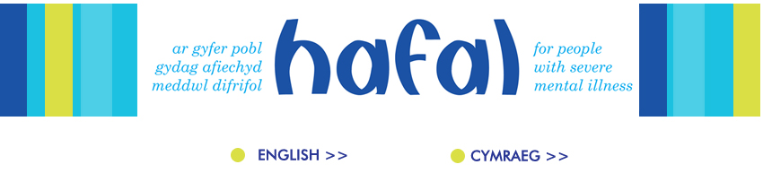
‘Thank you and the team for putting together the Mind the training event at Morlan, it certainly was most enjoyable and very beneficial experience.
As of tomorrow the exhibit of photos will be on display in the restaurant of Bronglais Hospital’
ASC attendees view of campaign and digital project "I especially like the immediacy of digital photography where you can take a picture and have it up on the screen to work on very soon after. Ms Kelly said she also felt very strongly about Hafal's campaign to reduce discrimination against people with mental health problems after her own experiences.
"I am quite a shy person and the discrimination I have experienced from when I was a young teenager made me feel much more threatened," she said.
Rik Mowbray, co-ordinator of Ceredigion social activities for Hafal, said Ms Kelly had been aided to follow her interests by facilities and support from the social club she attends.
Peter Davey, chair of Hafal, said the images on display in the Senedd covered all of life, from people and places, details and panoramas to colour and light. "But more importantly, what they show is that - whether we have a mental illness or not - we can all express our unique perspectives on life by observing the world through the camera," he said.
The campaign has also seen thousands of anti-stigma leaflets handed to the Welsh public.
The exhibition will also mark World Mental Health Day.
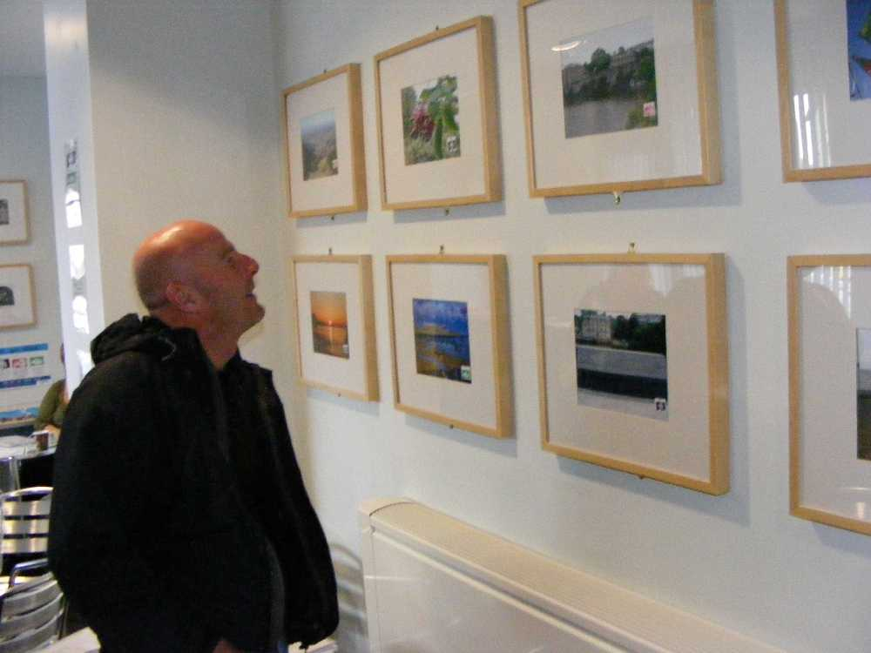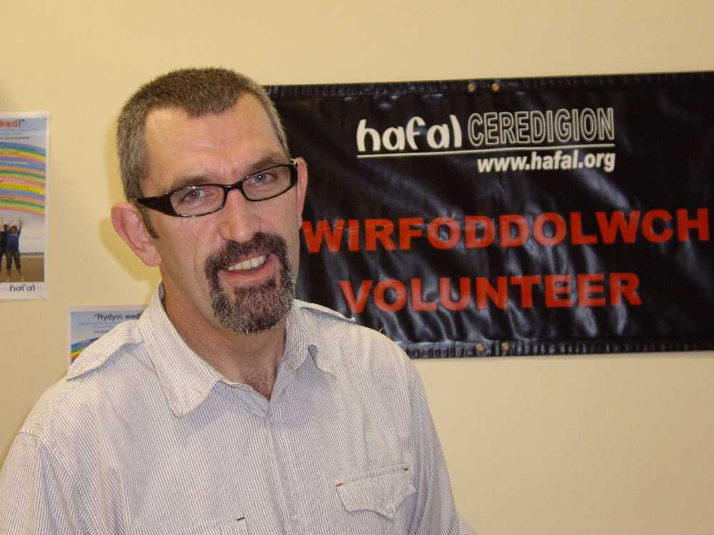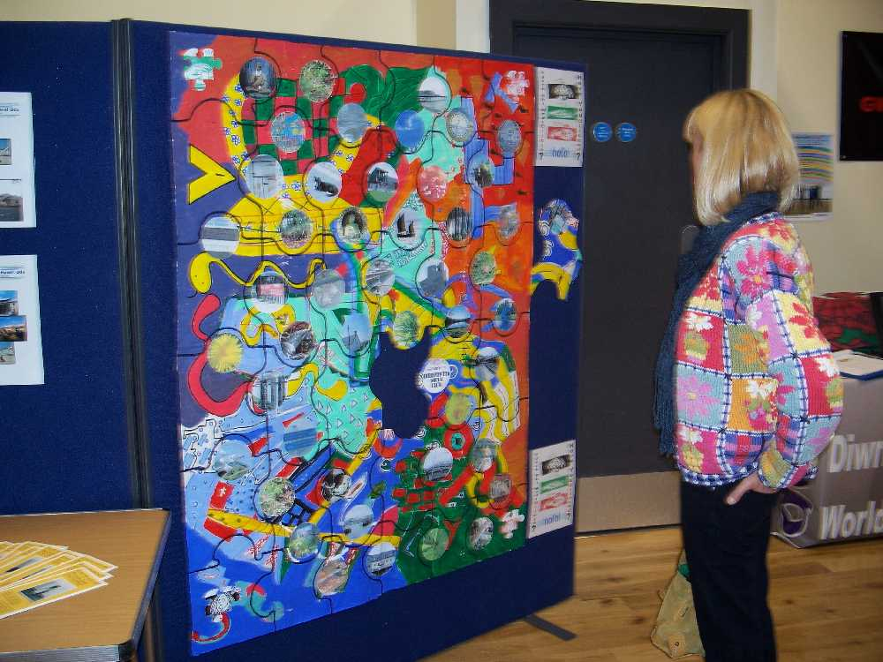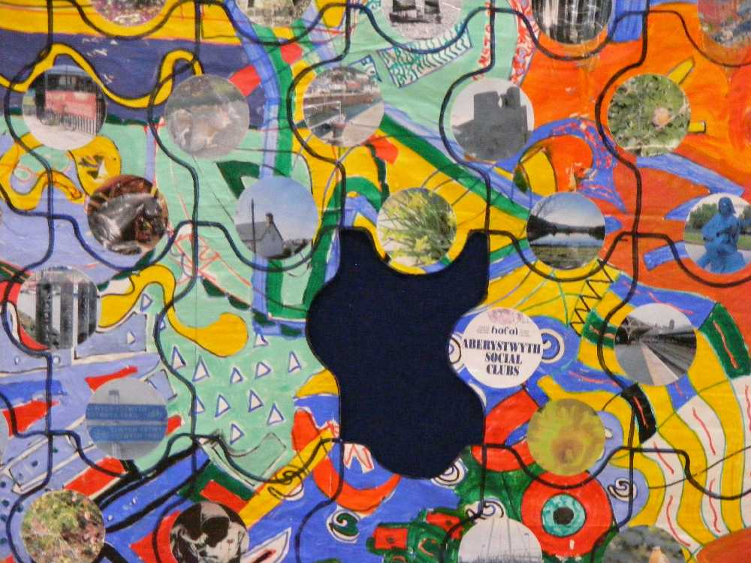
Advocacy Ceredigion
Information provided by Keith Williams, ‘November 3rd 2008 sees the launch of the statutory Independent Mental Health Advocacy Service (IMHA) in Wales. At the conference, advocates from Mental Health Advocacy in Pembrokeshire (MAP) were on hand to provide information about the new service and answer questions from delegates.
In partnership with South Wales Mental Health Advocacy (SWMHA), MAP is to provide the IMHA service to patients in Swansea, Neath & Port Talbot, Bridgend, Ceredigion, Pembrokeshire and the western Vale of Glamorgan.IMHAs are specialist advocates who are trained to work within the framework of the Mental Health Act. The service is free, confidential and independent.
IMHAs will work in a way that adheres to the patient’s wishes, empowers the patient and remains issue based. IMHAs will help patients obtain information about and understand:
- Their rights under the Act;
- The rights which other people have in relation to them under the Act;
- Any medical treatment that they are receiving or may receive;
- The parts of the Act which apply to them.
If you would further information please contact Mental Health Advocacy in Pembrokeshire, The Liberal Chambers, 4 St. Mary's Street, Haverforwest, Pembrokeshire SA61 2DR, or Telephone 01437 762935.’

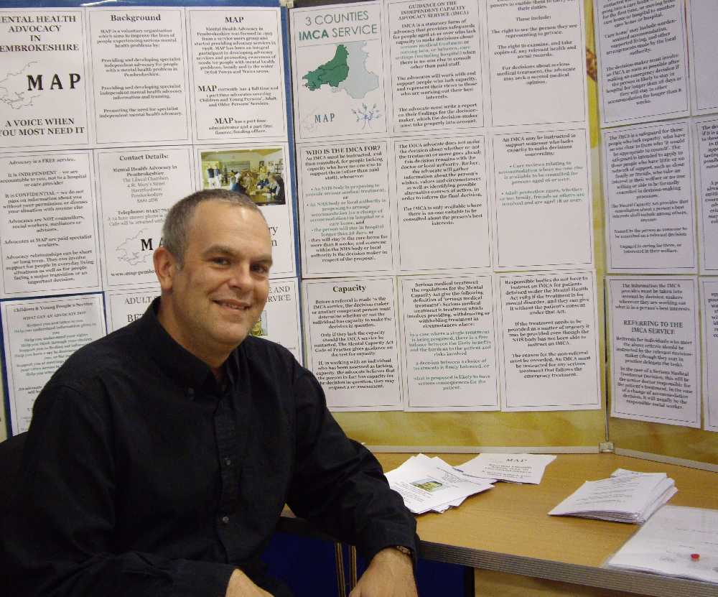
Page 4
Page 5
WHY? By Kathy Giles
Heads are shaking
People tutting
Yes, I am behaving strangely
But have they asked me WHY?
No-one will come near me
They all seem so afraid
Yes, I know that I am shouting
But no-one asks me WHY?
I am really hot and bothered
My head it hurts like hell
I feel disorientated
I want to know the reason WHY?
I am someone’s brother, sister, father, mother
I don’t always act like this
I really don’t feel quite myself
Will someone ask me WHY?
As children we drive adults to distraction
With what and where and why and when
So why as adults do we make assumptions
Have we forgotten the question WHY?
To all those who profess to care
Look beyond what you can see and
Try to find the person who is me
To do that, ask the question WHY?

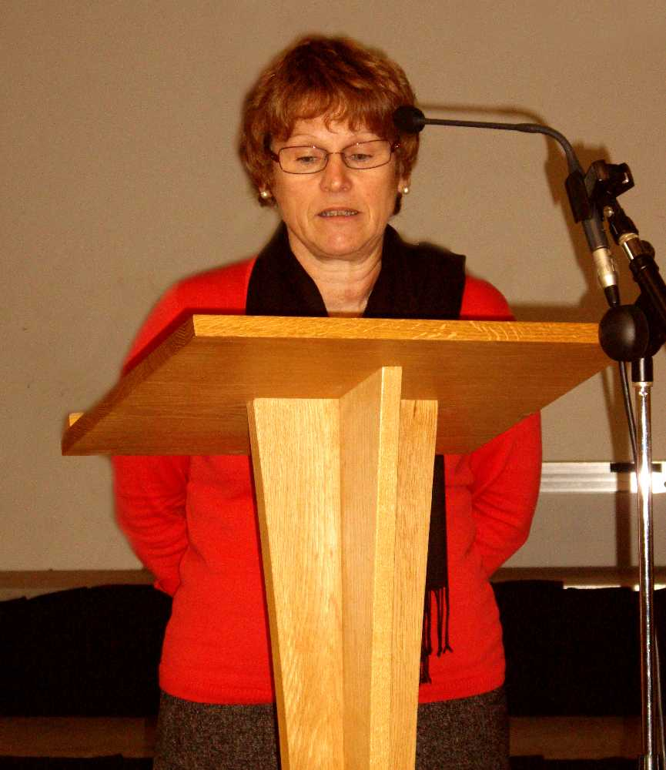

Adlerian Centre – Sarah Maynard

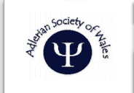

Comments from Sara Maynard… ‘We were just delighted to be there at the Mind The Gap event and to meet other professionals within the NHS that work in the field of Mental Health. We found the day very encouraging.We are fully aware that Counselling is one of the many ways that can help bridge the gap. From the referrals that we receive from local GPs we have had already a high success rate with clients that have been treated for mental health issues. This is a real area of opportunity for us to make a real difference in bridging the gap!’

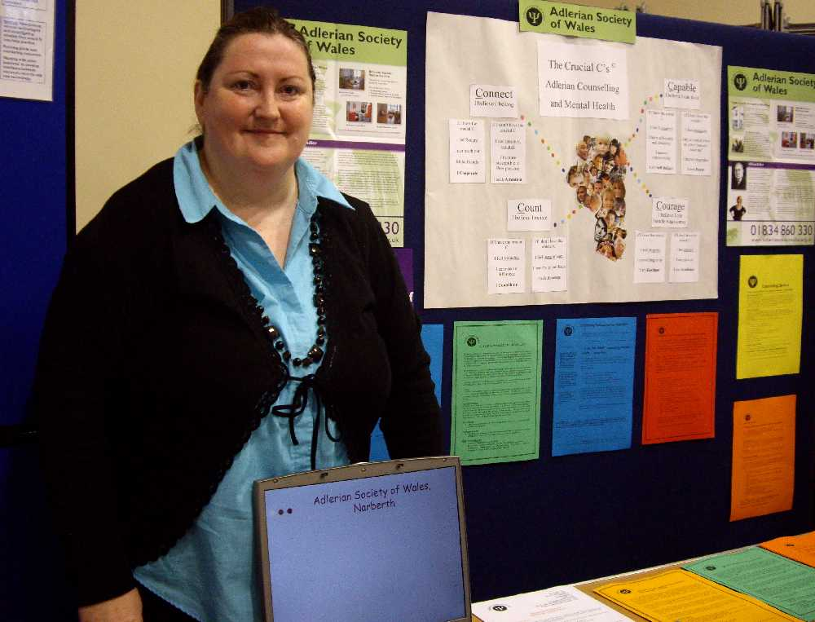
World Mental Health Day

The World Federation for Mental Health (WFMH) established World Mental Health Day in 1992. It is the only annual global awareness campaign to focus attention on specific aspects of mental health through local, regional and national and World Mental Health Day events

Prize for best poster/table display
Caroline Oakley had the difficult task of choosing the best poster/table displays, one representing the trust and the other from the voluntary sector. Hafal and Ceredigion CMHT both received prizes.

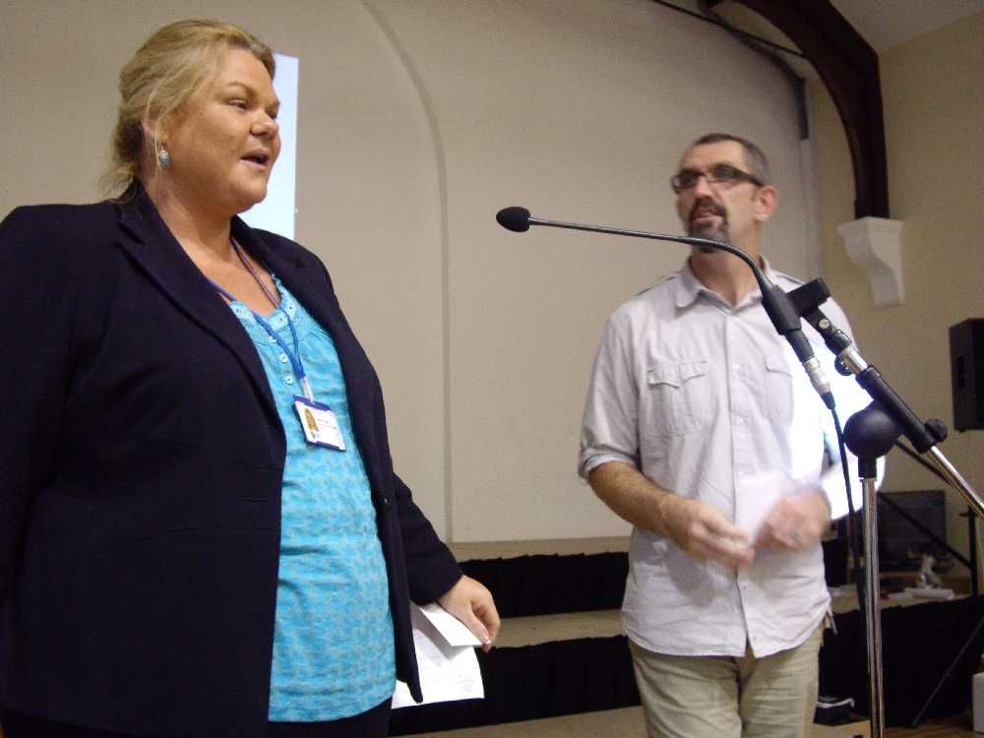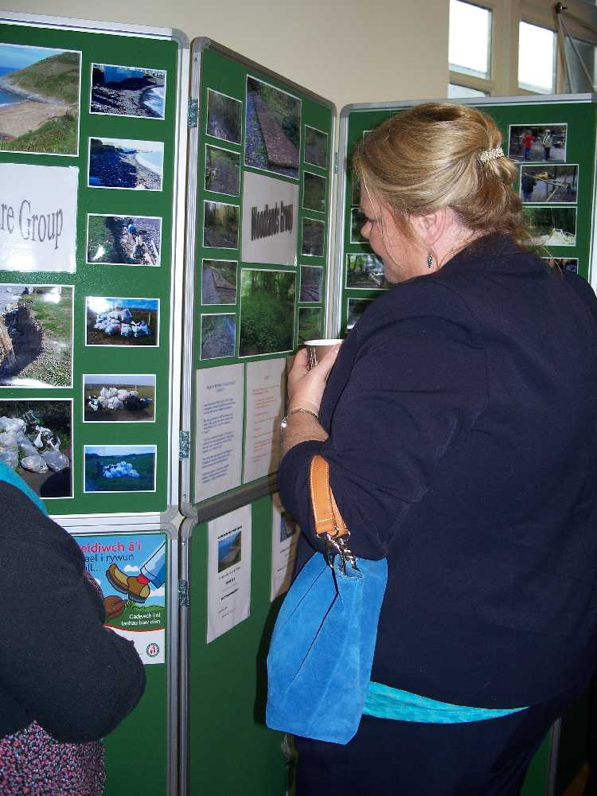
Page 3
Page 6

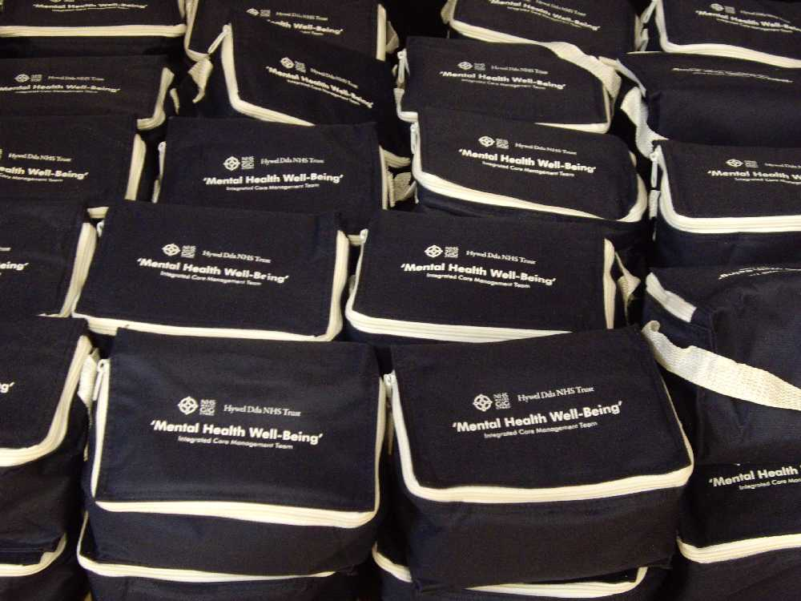

Comments from the day…

‘Very thought provoking’

‘Please do more of these, it is really important’

‘Provocative/challenging’

‘It was like putting together a complicated jigsaw’

‘A very enjoyable and appropriate way to promote mental health day, all presentations were professional and informative’

‘Useful for practice, particularly resources collected from various stands’

‘Looking forward to what may be available in the future’

‘Broadened my knowledge’

‘We all have a role to play in raising awareness, reducing stigma and playing a part in such an area’

‘Through working together in this way we can have a stronger voice and make an effective change’

‘Thought provoking and empowering’

‘Good to network with other agencies’

‘Very well organised’



The ICM Team would like to thank…

Caroline Oakley, Andrea Higgins,Richard Jones, Kathy Giles, Hassen Joomraty, I.T departments within the trust for circulating the information, Jan Batty (Mind your heart), Carol and Alun at Morlan, Simon Tudor at Dyfed Powys Police, Lesley Kurdi, Bernard Moses and all the Catering staff at Hafan Derwen, Owain Phillips and all the team at Radio Ceredigion, Cambria news, Nia Gwyndaf at Aberystwyth University, Maggie Robinson, Mary Adams, Beverley Gardner, Nick Evans, CAMHs (Sue West, Diane Williams, Angela Lodwick), Enlli Ward ( Debbie Chattun, Sally Corlett), Learning Disabilities (Nigel Miller, Non Elias) , South Ceredigion CMHT (Tyrone Brown,Lesley Levy), Afallon (Christine Whipp, Lloyd Bloomfield), Ceredigion AOT (Donna Phillips, Robert Miles, Kate Lewis, David Corlett), Primary Care Mental Health Team (Tamsin Meriel), Annette Jones (Well Being Programme), David Rabjohns (WWAMH), Joyce Borgs (Mind Aberystwyth), Julia Andrew (Crossroads), Sally Waters (Condition Management Programme), Rik Mowbray and Bob Mathias (Hafal), Advocacy( Keith Williams), Adlerian Centre Narberth (Sarah Maynard and team) and for all those who attended on the day.



